Technical Specifications

Project Title: “Capacity Building Support to the Implementation of the Integrated Planning System (IPS 2)”
Contract Title: IT Equipment for the DDGG and PMO
Ref. No. AL-IPS2-P129332-SH-2.03.07.

Background
The project Second Multi-Donor Trust Fund, related to capacity building support to the implementation of the Integrated Planning System (IPS 2) in Albania, has ensured a progressive enhancement of the IPS system in general. So far, the project has already ensured consolidated pillars of the IPS system, by contributing to the finalization and approval of the NSDI 2015-2020, as well as enhancing capacities related to the PFM reform in general, and especially to the MTBP implementation. The support provided through the TA regarding the PFM reform strategy has been incremental to the Budget Support process that has been initiated for this sector, and has ensured complementarity to the EU related support.
The project is ensuring the implementation of the three management information systems, namely EAMIS (partially implemented) and AFMIS, IPSIS, which are currently under implementation and are considered complex, but in the same time crucial, systems for the modernization of the public administration in general. AFMIS modules are developed, meanwhile for IPSIS, the modules have been developed so far, ICT infrastructure (hardware and software) is finalized.
The project is supported through a multi-donor trust fund financed by Sweden, Switzerland and EU, the grant is administered by the World Bank and is executed by the Ministry of Finance and Economy.

The Project objective is to strengthen the implementation of the Integrated Planning System, by creating the conditions for introducing a performance orientation in the policy planning and budgetary processes and by improving institutional capacity to monitor results at the strategy and program levels.

The key implementing agencies for IPS 2 TF Project are the Ministry of Finance and Economy and the Department of Development and Good Governance (DDGG) in the Prime Minister Office.

The Central Finance and Contracting Unit nearby the Ministry of Finance and Economy is the responsible implementing unit for managing the timely implementation of project activities, including managing the day-to-day aspects of project procurement and financial management and monitoring and reporting of progress on contracts’ execution.

Objectives
This assignment aims to provide for the Department for Development and Good Governance (DDGG), in the Prime Minister Office (PMO).

Items and descriptions for IT Equipment for the DDGG and PMO

No. | Description | Quantity
Item 1 | Photocopy Multifunction High Volume Copy Machine | 1
Item 2 | Printer Colour Advanced | 5
Item 3 | Printer Toner cartridges set for item 2 | 8
Item 4 | Laptop Advanced | 5
Item 5 | Workstation Advanced | 1
Item 6 | Monitor for presentation 65 inch | 2

Items and descriptions for IT Equipment for the Department for Development and Good Governance (DDGG), in the Prime Minister Office (PMO).

TECHNICAL SPECIFICATIONS FOR DATA CENTER EQUIPMENT OF DDGG

Item 1 Photocopy Multifunction High Volume Copy Machine (1 unit)

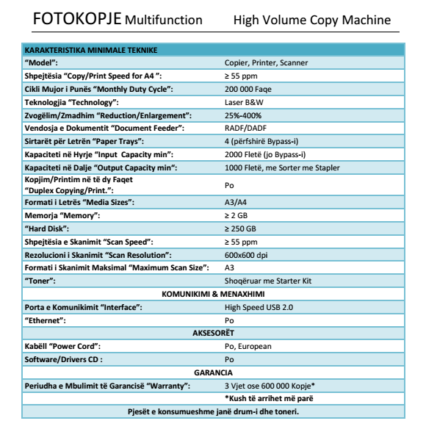

Item 2. Printer Colour Advanced (5 units)
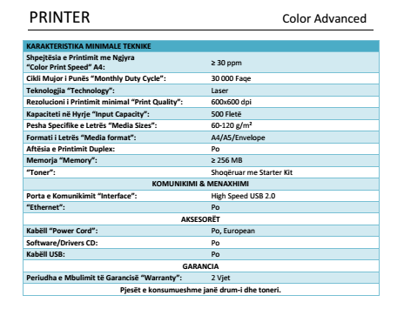

- Item 3. Printer Toner cartridges set for item 2 (8 Units)

N/A

Item 4. Laptop Advanced (5 Units)
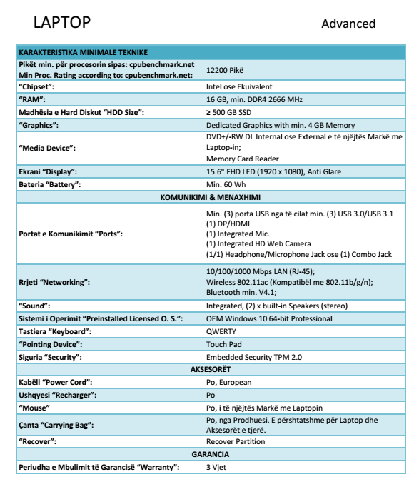

Item 5. Workstation Advanced (1 unit)
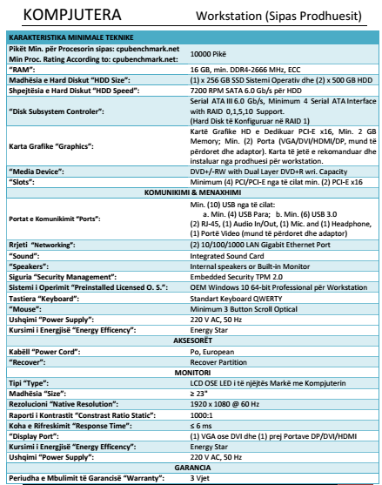

Item 6. Monitor for presentation 65 inch (2 units)

Minimum Technical Requirements
Type | LCD, IPS Monitor
Size | 65”
Native Resolution | 1920 x 1080 @ 60 Hz
Constrast Ratio Static | 1000:1
Display Port | (1) VGA (1) DisplayPort; (1) HDMI
Response Time | 5 ms
Connectivity | LAN, WiFi Connectivity and Bluetooth for internet and peripherials.
Camera | Conderence camera incorporated HiFi resolution  Movable camera
Microfon | Externel, compatibel with Monitor
Web Camera | HD Externel, compatibel with Monitor
Home cinema | Externel
Ergonomics | Tilt adjustment: -5 to +20°; Swivel: ±45°; Pivot rotation: 90°
Energy Efficency | Energy Star
Power Supply | 220 V AC, 50 Hz
Warranty | 3 Years, with global support as webex etc.
Other requirements:
- Supply and installation of equipments on DDGG premises
- Delivery time, within 30 June 2020

